## **Study Title: Santee Accord Diadromous Fish Studies**

## **Period Covered: January 2025—December 2025**

**Introduction**

The Santee Basin Cooperative Accord (Accord) is a collaborative approach among the hydroelectric utilities and state and federal resource agencies to address diadromous fish issues within the Santee Basin. Partners include Dominion Power, (formerly known as South Carolina Electric & Gas), Duke Energy, South Carolina Department of Natural Resources (SCDNR), North Carolina Wildlife Resource Department, and US Fish and Wildlife Service (FWS). The Accord allows members to focus efforts on the highest priority areas with the greatest potential for successful results, rather than addressing issues piecemeal based on project relicensing schedules. In exchange for the utilities agreeing to combine and focus efforts by priority sub-basin, the FWS agrees to reserve authority or prescribe phased and or delayed fish passage at lower priority sub-basins. Combining funding and focusing efforts on high priority habitats will produce (1) a collaborative and concentrated response to depressed diadromous fish populations, (2) a program guided by biological responses, and (3) will provide economic assurances to utility companies. This 10-Year Action Plan for the Santee Basin represents the next phase and evolution of the Santee Plan. This Action Plan recognizes the Broad River sub-basin as having the highest priority and potential for successful restoration of diadromous fish, and details in logical steps those activities necessary to rebuild fish populations. The basic tenet of this Action Plan is to rebuild diadromous fish populations in upstream river reaches through enhancement activities and construct permanent passage facilities at dams as stocks rebuild. This plan is to use a combination of enhancement activities including hatchery techniques resulting in fry augmentations, re-locations of pre-spawning adults, and permanent passage facilities as they become warranted. The plan designates 10 task areas for studies, and this report focuses on task 4 in the plan.

*Task 4. Juvenile Shad Monitoring in Nursery Waters and Shad Fin Clip Collection*

Purpose: To collect sufficient young-of-year (YOY) juvenile American shad (AMS) to determine abundance, distribution, size, and out-migration timing. In years past, shad fin clips were collected for genetic analyses of natural versus hatchery shad; however, no fin clips were collected this year.

**Materials and Methods**

*Sampling Sites*

Due to the loss of dedicated funding and crew, sampling in the Santee Basin only occurred at three sites in the Congaree River, and four in the upper Santee River this year (Figures 1–2). This sampling was conducted by SCDNR WFF Region IV staff. Sampling sites on rivers were selected from satellite imagery based on areas that were presumed to be preferred nursery habitat for YOY AMS. These habitats typically consist of sandbars occurring on the inside bend of rivers, ranging 1–2 meters (m) depth.

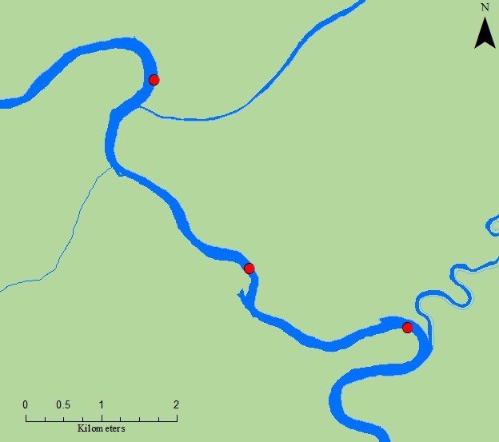

Site #3

Site #2

Site #1

US 601

Figure 1. Congaree River sampling sites

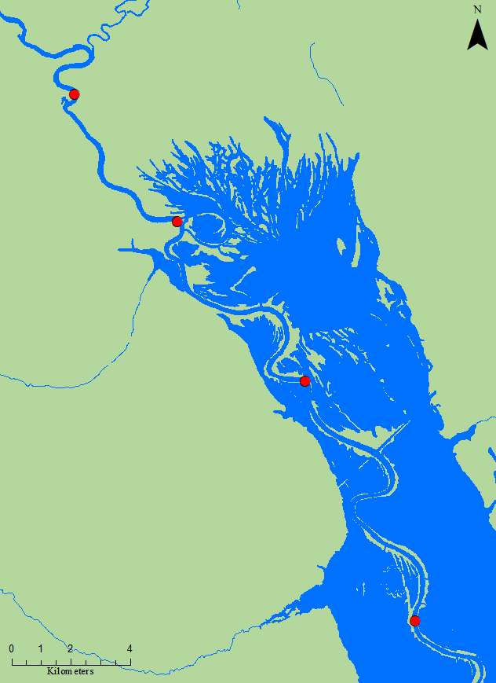

Site #4

Site #3

Site #2

Site #1

Figure 2. Upper Santee River sampling sites.

*Juvenile AMS Collections*

Electrofishing occurred from Junethrough October (22 weeks) for a total of 6 sampling trips at all sites on both the Santee and Congaree rivers. River sites were visited during daylight hours, with a goal sampling frequency of three times per month, during which a single 0.25-hr sample per site was conducted. All fish collected were identified to species and total length was recorded to the nearest millimeter (mm). In past years, after sampling concluded for the season, otoliths were extracted from preserved shad and viewed under a UV fluoroscope to identify fish displaying an oxytetracycline (OTC) mark, thus indicating a fish of hatchery origin. On January 1, 2017, the Food and Drug Administration issued a new rule that all veterinary antibiotics will be accessible only with veterinary oversight. OTC is a veterinary antibiotic and because of the change in the law, SCDNR chose to no longer mark AMS using OTC. Consequently, for the 2017 sampling season and thereafter, pectoral fin clips were collected for later analysis for DNA matches with hatchery brood stock, thus indicating fish of hatchery origin. Starting in 2024, fin clips were no longer collected.

*Adult American Shad Collections*

During the 2015 Santee Accord board and technical committee meeting, funds were approved to explore the possibility of expanding the current study design to collect adult AMS during their spawning run from areas similar to where electrofishing for juvenile shad occurs. This was done to help determine if any AMS return spawners within the Santee River Basin are comprised of hatchery origin fish. A combination of drift-gillnets and electrofishing was used to collect specimens, and pectoral fins of captured adult AMS were clipped for future lab analysis. No adult AMS sampling occurred during the2024 season due to the loss of a dedicated crew and funding.

**Results and Discussion**

*Sampling Results*

Juvenile shad were collected from June 2 to October X, 2025. In total, 249 juvenile AMS were collected from 37,667 seconds of electrofishing time, generating an overall CPUE of 0.40 AMS/minute (Table 1). Collected juvenile AMS ranged from 31177 mm, total length. Individual totals per river per site are listed in Table 1. In years past, a subsample of 20 AMS per site were frozen and fin clips will be extracted during the following winter months. However, this procedure was not followed again this year due to financial and crew constraints, and the current backlog of previous examples to be processed. Observed ranges for water quality parameters during sampling were as follows: temperature, 21.5-25.6°C; dissolved oxygen, 3.06-6.98 mg/L; conductivity, 78.0-114.8µS; salinity, 0.00-0.10 ppt. Due to sampling efforts being divided up this year between the regions and not having a dedicated crew, species identification of shiners, minnows, and darters was not consistent and were not included in species composition or counts. Electrofishing efforts of most abundant species totaled 1994 fish (Figure 3). Water quality was not taken at majority of Santee sites this year due to a broken YSI meter.

|  |  |  |  |  |  |
| --- | --- | --- | --- | --- | --- |
| **Sampling Location** |  | **# Sampling Trips** | **Total Pedal Time (s)** | **# AMS** | **CPUE (#AMS/minute)** |
| **Congaree River** |  |  |  |  |  |
| Bar upstream of HWY 601 (E) |  | 6 | 5400 | 12 | 0.13 |
| Bar downstream of HWY 601 (F) |  | 6 | 5400 | 9 | 0.10 |
| Congaree/Wateree Confluence (G) |  | 6 | 5400 | 28 | 0.31 |
|  | **Totals** |  | **16200** | **49** | **0.18** |
|  |  |  |  |  |  |
| **Upper Santee River** |  |  |  |  |  |
| Bar upstream of Trezvants (D) |  | 6 | 5400 | 47 | 0.52 |
| Bar upstream of Week's Landing (A) |  | 6 | 5267 | 25 | 0.28 |
| Bar upstream of Low Falls RR (B) |  | 6 | 5400 | 69 | 0.77 |
| Bar upstream of the Blowout (C) |  | 6 | 5400 | 59 | 0.66 |
|  | **Totals** |  | **21467** | **200** | **0.56** |

|  |  |  |  |  |
| --- | --- | --- | --- | --- |
|  |  |  |  |  |
|  |  |  |  |  |
|  |  |  |  |  |
|  |  |  |  |  |
|  |  |  |  |  |
|  |  |  |  |  |
|  |  |  |  |  |
|  |  |  |  |  |
|  |  |  |  |  |
|  |  |  |  |  |
|  |  |  |  |  |
|  |  |  |  |  |

### Table 1. Sampling locations, # of trips, effort, # of juvenile shad collected, and CPUE for 2025

### Figure 3. Total composition of top 10 species collected. Fish common names with the three letter abbreviations are provided in Appendix 1.

*Juvenile AMS Catch Rates*

Statistical analysis of data from 2009 to 2016 indicated an overall trend of increase-peak-decrease in catch rate in this time series (Post and Holbrook 2016). The increase-peak-decrease trend is most likely a result of a combination of changing environmental and ontogenetic factors as the sampling season progresses. Stokesbury and Dadswell (1989) reported water temperature to be a leading factor for juvenile AMS migration, suggesting that YOY AMS movement was triggered by temperatures ranging from 12–19°C, depending on moon phase. Similarly, 4–6°C was suggested as a lower threshold temperature limit for YOY AMS before emigrating completely from freshwater (Chittenden 1969; Marcy 1976). Another potential cue for outmigration is body size, where larger, typically older, individuals have been found in the downstream portion of rivers earlier than their smaller bodied conspecifics (Limburg 1996). Sampling locations are located near spawning and nursery habitat and, in the fall of the year as water temperatures cool and fish continue to grow, fewer AMS tend to be caught (Figure 4), most likely because downstream migrations have already occurred.

In 2025, catch rate and day of year (DOY) were plotted for juvenile AMS samples collected in the Congaree and Upper Santee Rivers (Figure 4).Data indicates an increase in catch in early summer with a slight peak by mid-June during optimal water temperatures. This was followed by a delay in AMS outmigration as water temperatures remained consistently above 20°C throughout summer months. A drop below 20°C occurred in mid-October and catch rates decreased but remained positive, suggesting the sampling period ended before the YOY outmigration was complete.Sampling efforts were less than in prior years, as the sampling procedure has transitioned to regional staff with the primary goal of maintaining the sampling array in the Santee and Congaree Rivers. There were substantially less AMS caught this year and a decrease in effort due to scheduling conflicts between regional staff. Water quality metrics, specifically water temperature, were not recorded at all of the sites this year.

Figure 4. Catch rates of juvenile AMS and water temperature throughout the upper Santee River Basin (Congaree, and Upper Santee Rivers) in 2024. Catch rate is equal to number of AMS per minute of sampling and DOY is day of calendar year.

### Figure 5. Number of juvenile AMS collected and total sample effort throughout the upper Santee River Basin, the Diversional Canal, and Lakes Marion and Moultrie from 2009 through 2023. In 2024, only the Upper Santee and Congaree Rivers were sampled.

*Adult AMS Catch Rates*

No Adult AMS sampling occurred in 2024 and onwards due to the lack of a dedicated crew and funding. Data trends for Adult AMS sampling in the Upper Santee System for the last 5 seasons are compared (Figure 6).

Figure 6. Monthly catch rates for adult AMS in the Upper Santee River (2019–2024).

**Recommendations**

Sampling will continue in 2025 but will be conducted by regional SCDNR employees and slight changes in study design may occur, similar to 2024 sampling. The new genetic analysis study will be used to determine overall hatchery contribution to the system and to evaluate the success of the Santee-Cooper River Basin AMS stocking program as a whole. Data will continue to be used to demonstrate sustainability for the Santee and Cooper Rivers as part of ASMFC’s American Shad Sustainability Plan for South Carolina. No genetic sampling was done this year or will be done in the future.

**Literature Cited**

Chittenden, M.E. 1969. Life history and ecology of the American Shad, *Alosa sapidissima*, in the Delaware River. Doctoral dissertation. Rutgers University, New Brunswick, New Jersey.

Limburg, K.E. 1996. Growth and migration of 0-year American Shad (*Alosa sapidissima*) in the Hudson River estuary: Otolith microstructural analysis. Canadian Journal of Fisheries and Aquatic Sciences 53: 220-238.

Marcy, B.C., Jr. 1976. Early life history studies of American Shad in the lower Connecticut River and the effects of the Connecticut Yankee Plant. Pages 141–168 *in* D. Merriman and L.M. Thorpe, editors. The Connecticut River ecology study: The impact of a nuclear power plant. American Fisheries Society Monograph No. 1, Bethesda, Maryland.

Post, B. and Holbrook, C. 2016. Diadromous Fish Project Annual Progress Report, SCR1-39, 244 pp.

Stokesbury, K.D.E., and Dadswell, M.J. 1989. Seaward migration of juveniles of three herring

species, *Alosa*, from an estuary in the Annapolis River, Nova Scotia. The Canadian

Field-Naturalist 103: 388-39.5293685

## Title:

## Fisheries Technician

## Fisheries Biologist

## Prepared By:

## Erica Schmidt

## Kyle Hoffman

Appendix 1.Common names and abbreviations of fish collected using boat electrofishing equipment.

|  |  |  |  |  |
| --- | --- | --- | --- | --- |
| American Shad | AMS |  | Longnose Gar | LNG |
| Atlantic Needlefish | ANF |  | Mosquito Fish | MSQ |
| Blackbanded Darter | BBD |  | Notchlip Redhorse | NLR |
| Blue Catfish | BCF |  | Quillback | QLB |
| Bowfin | BFN |  | Redbreast Sunfish | RBS |
| Bluefin Killifish | BFK |  | Redear Sunfish | RES |
| Black Crappie | BLC |  | Seminole Killifish | SEK |
| Bluegill | BLG |  | Shorthead Redhorse | SHR |
| Blueback Herring | BLH |  | Smallmouth Buffalo | SLB |
| Brassy Jumprock | BJR |  | Smallmouth Bass | SMB |
| Brook Silverside | BSS |  | Spotted Sunfish | SOS |
| Channel Catfish | CCF |  | Spotted Sucker | SPS |
| Chain Pickerel | CHP |  | Striped Mullet | SRM |
| Common Carp | CRP |  | Striped Bass | STB |
| Coastal Shiner | CSH |  | Spottail Shiner | STS |
| Dollar Sunfish | DSF |  | Tadpole Madtom | TPM |
| Eastern Silvery Minnow | ESM |  | Threadfin Shad | TFS |
| Flathead Catfish | FCF |  | Tessellated Darter | TSD |
| Grass Carp | GCP |  | Warmouth | WAR |
| Golden Shiner | GLS |  | White Catfish | WCF |
| Gizzard Shad | GZS |  | Whitefin Shiner | WFS |
| Highfin Carpsucker | HFC |  | White Perch | WTP |
| Inland Silverside | ILS |  | Yellow Bullhead | YBL |
| Lake Chubsucker | LKC |  | Yellow Perch | YLP |
| Largemouth Bass | LMB |  |  |  |